1.Barley Roti :

Reference :
- Bhojana Kutuhala Siddhannaprakarana (Dhanyavishesha and Bhakshyavishesha), p. 13 and 51
- ICMR – National Institute of Nutrition (NIN). Dietary Guidelines for Indians, 2024.

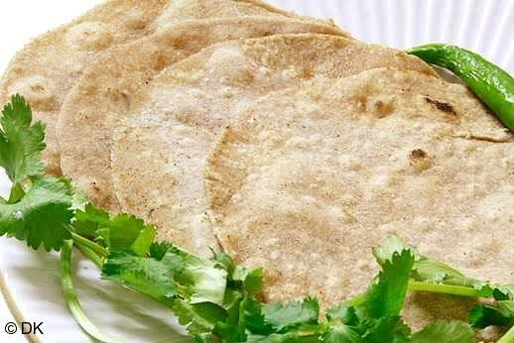
Credit -31e1e94206823703736d782beb728d77.jpg (518×346)

Ingredients :
Barley flour – 80-100 gm (½ cup)
Water – as needed for a soft dough
Rock salt – a pinch (to taste)
Ghee – 4-6 ml (about 1 teaspoon)

Total quantity: 2-3 medium roti

Method of preparation :
- Take a barley flour in a mixing bowl add pinch of rock salt (if desired) and mix well. Gradually add water and knead into soft and smooth dough (use warm water for kneading to obtain soft rotis) cover the dough and rest it for 15-20min.
- Make equal sized ball into dough and dust each ball with a little quantity of flour and roll it into thin, round roti.
- Heat a tawa on medium flame and place the rolled roti on it and apply ghee, cook until small bubbles appear then flip the roti and cook the other side by applying the ghee and gently press with spatula for the roti puffs up (put ghee on to the roti, if desired).
- Serve hot with curry or dal or chutney.

2. Royal blackgram stuffed parata (Vedanika) :

Reference :
- Bhojana Kutuhala Siddhannaprakarana (Bhakshyavishesha), p. 53
- ICMR – National Institute of Nutrition (NIN). Dietary Guidelines for Indians, 2024.

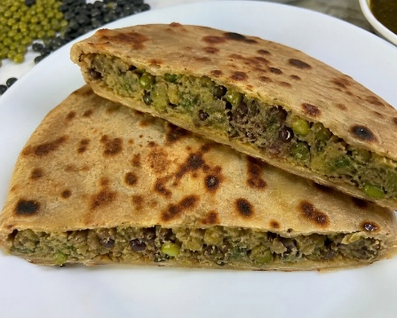
Image generated with use of AI

Ingredients :
Wheat flour – 80-100 gm (1/2 cup)
De-husked black gram – 50-70 gm (1/4 -1/3 cup)
Water – As needed for soft dough
Sesame oil – 10-20 ml (2 teaspoon – 4 teaspoon)
Ghee – 10-20 ml (2 teaspoon – 4 teaspoon)
Rock salt – a pinch (to taste)

Total quantity: 2-3 medium Vedanika

Method of preparation :
- Soak the de-husked black gram for 6-8hrs or overnight then grind it in a mixer to obtain a smooth paste.
- Take wheat flour in a mixing bowl add pinch of rock salt (if desired) and mix well. Gradually add water and knead into soft and smooth dough cover the dough and rest it for 15-20min.
- Make equal sized balls from the paste for the filling purpose and divide the dough into equal portions, flatten a dough ball place the paste in the centre and seal edges.
- Dust a little quantity of flour and roll it into thin and round roti. Heat a tawa on medium flame and place the rolled roti on it and apply ghee or sesame oil, cook until small bubbles appear then flip the roti and cook the other side by applying the ghee or sesame oil. Cook until golden brown spots appear and serve hot with ghee (if desired) and any side dish of your choice.

3. Royal blackgram stuffed Puri (Vadori) :

Reference :
- Bhojana Kutuhala Siddhannaprakarana (Bhakshyavishesha), p. 53
- ICMR – National Institute of Nutrition (NIN). Dietary Guidelines for Indians, 2024.

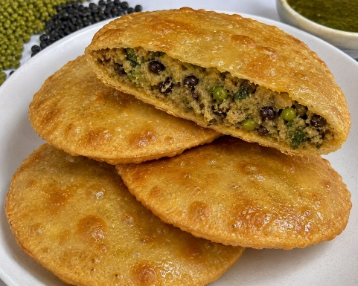
Image generated with use of AI

Ingredients :
Wheat flour – 80-100 gm (1/2 cup)
Black gram – 50-70 gm (1/4-1/3 cup)
Water – As needed for soft dough
Ghee – for deep frying
Rock salt – a pinch (to taste)

Total quantity: 2-3 medium Vadori

Method of preparation :
- Soak black gram for 6-8hrs or overnight then grind it in a mixer to obtain a smooth paste.
- Take wheat flour in a mixing bowl, gradually add water and knead into soft and smooth dough.
- Make equal sized balls from the paste for the filling purpose and divide the dough into equal portions,
- Flatten a dough ball place the paste in the centre and seal edges. Apply a little oil and roll it into thin and round roti.
- Heat ghee in deep frying pan. Once the ghee is hot gently slide a rolled poori into the ghee.
- Press lightly with a slotted spoon to help it puff up the flip and fry until both sides become golden brown.
- Remove and drain excess ghee on a paper towel and serve hot with any side dish of your choice.

4. Black gram Roti :

Reference :
- Bhojana Kutuhala Siddhannaprakarana (Bhakshyavishesha), p.66
- ICMR – National Institute of Nutrition (NIN). Dietary Guidelines for Indians, 2024.

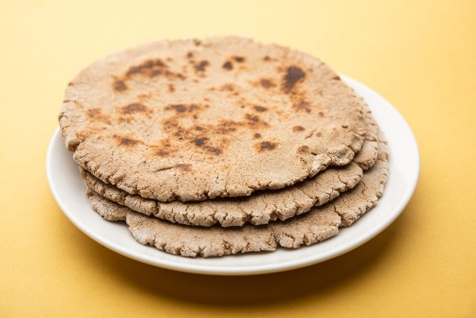
Image generated with use of AI

Ingredients :
Black gram flour – 80 - 100 gm (1/2 cup)
Water – as needed for a soft dough
Rock salt – a pinch (to taste)
Ghee – 5-10 ml (1teaspoon – 2 teaspoon)

Total quantity: 2-3 medium roti

Method of preparation :
- Take black gram flour in a mixing bowl add pinch of rock salt (if desired) and mix well. Gradually add water and knead into soft and smooth dough cover the dough and rest it for 15-20min.
- Make equal sized ball into dough and dust each ball with a little quantity of flour and roll it into thin, round roti.
- Heat a tawa on medium flame and place the rolled roti on it and apply ghee, cook until small bubbles appear then flip the roti and cook the other side by applying the ghee and gently press with spatula for the roti puffs up (apply ghee, if desired).
- Serve hot with curry or dal or chutney.

5. Wheat Roti :

Reference :
- Bhojana Kutuhala Siddhannaprakarana (Bhakshyavishesha), p.66
- ICMR – National Institute of Nutrition (NIN). Dietary Guidelines for Indians, 2024.

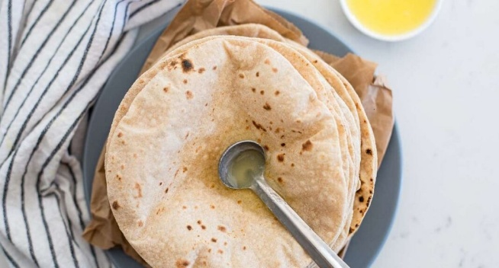
Credit:ghee-chapati-benefits-1068x561.jpg (1068×561)

Ingredients :
Wheat flour – 80-100 gm (1/2 cup)
Milk – as needed for soft dough
Ghee – 5-10 ml (1teaspoon-2teaspoon)
Rock salt (optional) – a pinch (to taste)

Total quantity: 2-3 medium roti

Method of preparation :
- Take wheat flour in a mixing bowl, gradually add milk and knead into soft and smooth dough. cover the dough and rest it for 5-10min.
- Make equal sized ball into dough and dust each ball with a little quantity of flour and roll it into thin, round roti.
- Heat a tawa on medium flame and place the rolled roti on it and apply ghee, cook until small bubbles appear then flip the roti and cook the other side by applying the ghee and gently press with spatula for the roti puffs up (apply ghee if desired).
- Serve hot with curry or dal or chutney.

6. Baati (Angarakarakati) :

Ref :
- Bhavaprakash Nighantu 12/33-34,
- Bhojana Kutuhala Siddhannaprakarana (Bhakshyavishesha), p. 51
- Kshema Kutuhala, 10 th Utsava
- ICMR – National Institute of Nutrition (NIN). Dietary Guidelines for Indians, 2024.

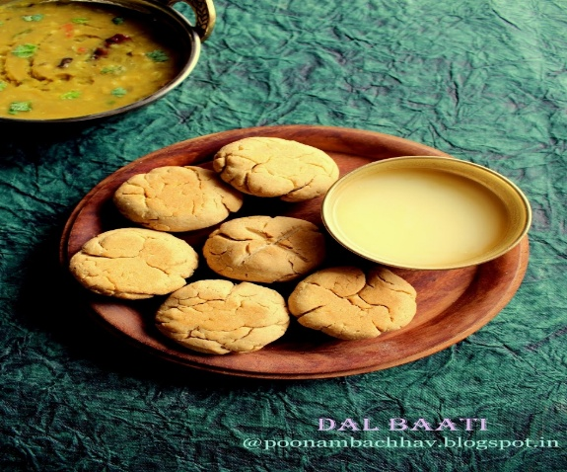
Credit: IMG_3203.JPG (1066×1600)

Ingredients :
Wheat flour – 80-100 gm (1/2 cup)
Water – As needed for dough
Rock salt – pinch (to taste)

Total quantity: 2-3 medium baati

Method of Preparation :
- Take wheat flour in a mixing bowl add pinch of rock salt (if desired) and 3-4tsp. of ghee mix well. Gradually add water and knead into firm dough. Cover the dough and allow it to rest for 15-20 min.
- Divide the dough into equal portions and make a medium sized round ball. Place these balls over the coal embers or a wire rack above the charcoal
- OR Bake in a preheated oven at 180⁰C for 25-30 min.
- OR use Air fryer by smearing the paper with oil and then place the balls on to the paper for 15 - 20 mins.
- OR use preheated pressure cooker for 10 min, with a layer of salt or sand at the bottom of a cooker. Place the wheat balls on a rack and cook on low flame for 30-40min. turning occasionally.
- OR use thick bottomed pan over low flame gas stove turning occasionally, once partially cooked, roast them directly over a low flame for a few min. to achieve golden brown colour.
- Remove the cooked balls from heat and allow them to cool slightly, then dip it in melted ghee or pour ghee generously over it and serve with dhal.

7. Vada (Vataka) :

Reference :
- Bhojana Kutuhala Siddhannaprakarana (Vatakavishesha), p. 54
- ICMR–National Institute of Nutrition. Dietary Guidelines for Indians. Hyderabad: NIN; 2024.
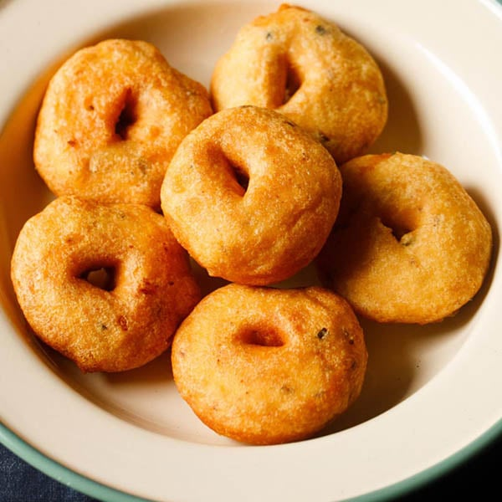
Credit: vada-recipe-1.jpg (600×600)

Ingredients :
De-husked black gram – 80-100 gm (1/2 cup)
Rock salt – a pinch (to taste)
Wet ginger paste – 2 gm (1/4 tsp)
Hingu – 1 gm (1/8 tsp)
Oil – as required (for frying purpose)
Water – as required (for batter preparation)

Total quantity: 3-4 medium vada

Method of preparation :
- Wash de-husked black gram thoroughly and soak in water up to 4-6 hrs after that drain the water and grind the dal into smooth and thick batter by using required quantity of water and beat the batter until it becomes light and fluffy.
- Then add required quantity of rock salt, wet ginger paste and hing and mix the batter well.
- Heat the oil in deep frying pan over medium flame. Wet the hands with water, take a small quantity of batter and shape it into vada by make a hole in the centre.
- And carefully slide the vada into the hot oil deep frying until the both side of the vada becomes golden brown and crisp.
- Then remove and drain the excessive oil and serve with any side dish of your choice.

8. Pumpkin crunch bites (Kushmanda Vataka) :
Reference :
- Bhojana Kutuhala Siddhannaprakarana (Vatakavishesha), p. 54
- ICMR–National Institute of Nutrition. Dietary Guidelines for Indians. Hyderabad: NIN; 2024.

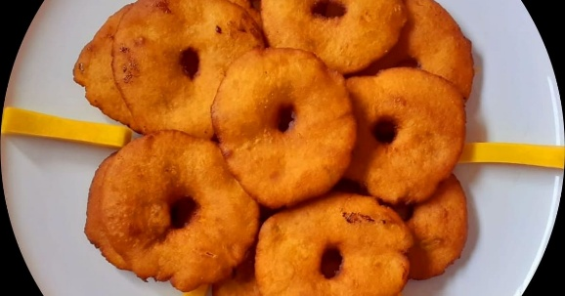
Credit:photo.jpg (1200×630)

Ingredients :
Black gram flour – 80-100 gm (1/2 cup)
Rock salt – a pinch (to taste)
Wet ginger paste – ¼ tsp
Hingu – 1 gm (1/8 tsp)
Black pepper – 0.5 gm (pinch)
Cumin seeds – 1 gm (1/8 tsp)
Fenugreek seeds – 1 gm (1/8 tsp)
Oil – as required (for frying purpose)
Water – as required (for batter preparation)
Pumpkin paste – 40-60 gm (1/4 cup)

Total quantity: 3 - 4 medium vada

Method of Preparation :
- Take Black gram flour in mixing bowl and add rock salt, wet ginger paste, hing, black pepper, fenugreek seeds and cumin seeds and add pumpkin paste and mix it well and gradually add water to make smooth and thick batter. beat the batter until it becomes light and fluffy.
- Heat the oil in deep frying pan over medium flame. Wet the hands with water, take a small quantity of batter and shape it into vada by make a hole in the centre.
- And carefully slide the vada into the hot oil deep frying until the both side of the vada becomes golden brown and crisp.
- Then remove and drain the excessive oil and serve with any side dish of your choice.

Samita preparation (refined wheat flour)
Ref:
Raghunathasurivirachita Bhojanakutuhalam Edited with English Translation, Notes and Illustrations by Scholars of the Centre for Theoretical Foundations (CTF), I-AIM(2012) Bhaksha Prakarana P.No :49
- Washed wheat grains thoroughly up to the grains turns into white then dried well and converted into flour (nicely powdered)

9. classical soft bread (Samita Roti (Mandaka)) :

Ref : Bhojana Kutuhala Siddhannaprakarana (Bhaksha prakarana), p.49
ICMR – National Institute of Nutrition (NIN). Dietary Guidelines for Indians, 2024.

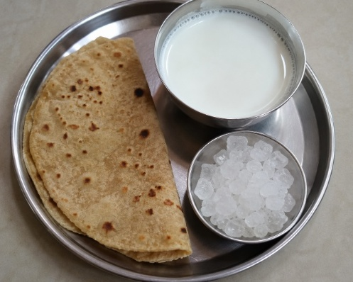
Image generated with use of AI

Ingredients :
Refined wheat flour – 80-100 gm (1/2 cup)
Water – as needed for soft dough

Total quantity: 2-3 medium roti

Method of Preparation :
- Take Refined wheat flour in a mixing bowl, gradually add water and knead well to make soft and smooth dough. cover the dough and rest it for 5-10min.
- Make equal sized ball into dough and dust each ball with a little quantity of flour and roll it into thin, round roti.
- Heat a tawa on medium flame and place the rolled roti on it and apply ghee, cook until small bubbles appear then flip the roti and cook the other side by applying the ghee and gently press with spatula for the roti puffs up.
- It should be served with milk, ghee and rock sugar.
10. Puri (Purika) :

Ref :Bhojana Kutuhala Siddhannaprakarana (Vatakavishesha), p.65
ICMR – National Institute of Nutrition (NIN). Dietary Guidelines for Indians, 2024.

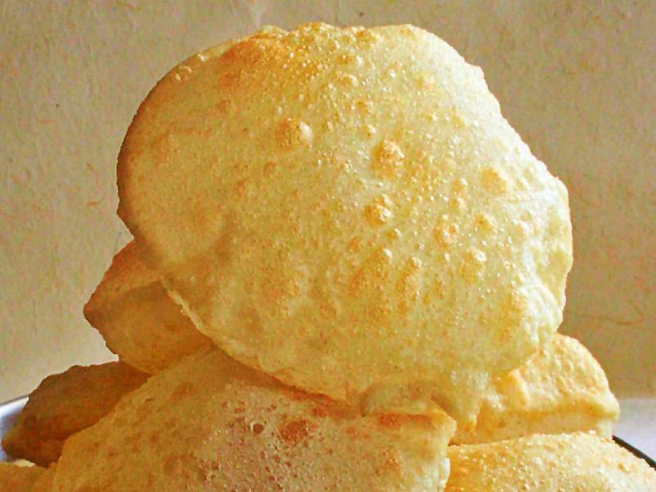
Credit :https://cocozil.com/images/cocozil/puri-poori-sm.jpg

Ingredients :
Refined wheat flour – 40-60 gm (1/4 cup)
Gram flour – 40-60 gm (1/4 cup)
Cumin seeds – 2 gm (1/2 tsp)
Hing – 1 gm (pinch)
Black pepper powder – 1 gm (2 pinch)
Ghee / Oil – as required (for deep frying)
Water – as needed for dough
Total quantity: 4 medium purika

Method of Preparation:
- Take equal quantity of Refined wheat flour and Gram flour in a mixing bowl add cumin seeds, hingu, black pepper powder mix well then add 2-3tsp. of ghee mix well then gradually add water and knead well to make soft and smooth dough.
- Make equal sized ball from the dough. By Appling little quantity of ghee / oil to the ball make ball into thin and round roti shaped purika.
- Heat ghee in deep frying pan. Once the ghee is hot gently slide a rolled purika into the ghee / Oil. Press lightly with a slotted spoon to help it puff up the flip and fry until both sides become golden brown.
- Remove and drain excess ghee on a paper towel and serve hot with any side dish of your choice.

11. Masala Puri (Candarika / Ghrtapura):

Ref : Bhojana Kutuhala Siddhannaprakarana (Vatakavishesha), p.65
ICMR – National Institute of Nutrition (NIN). Dietary Guidelines for Indians, 2024.

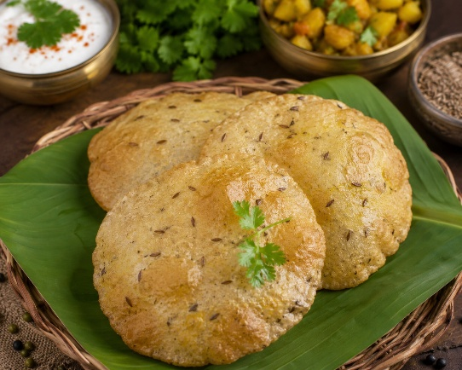
Image generated with use of AI

Ingredients :
Rice flour – 20-30 gm (1/4 cup)
Green gram flour – 20-30 gm (1/4 cup)
Black gram flour – 20-30 gm (1/4 cup)
Cumin seeds – 3-4 gm (1 tsp)
Hing – 1-2 gm (2 pinch)
Black pepper powder – 1-2 gm ( pinch)
Ghee / Oil – as required (for deep frying)
Water – as needed for dough

Total quantity: 4-6 medium Candrika

Method of Preparation :
- Take equal quantity of all the above-mentioned flour in a mixing bowl add cumin seeds, hingu, black pepper powder mix well then add 2-3tsp. of ghee mix well then gradually add water and knead well to make soft and smooth dough.
- Make equal sized ball from the dough. By Appling little quantity of oil to the ball make ball into thin and round roti shaped purika.
- Heat ghee in deep frying pan. Once the oil is hot gently slide a rolled purika into the Oil.
- Press lightly with a slotted spoon to help it puff up the flip and fry until both sides become golden brown.
- Remove and drain excess ghee on a paper towel and serve hot with any side dish of your choice.

12. Pumpkin and Big beans sweet pancake:

Ref: Traditional food recipes from Ayush systems of medicine

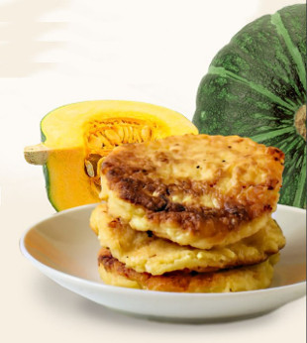
Credit: https://www.liveayurved.com/ayurveda_recipes/images/Pumpkin_Big_Beans_Pancake.jpg

Ingredients:
A ripe pumpkin cut into small pieces –150gm (¾ cup)
Cowpeas / Soybeans – 25gm (1/4cup)
Ragi fluor – 30 gm (1/4 cup)
Jaggery syrup – 15 ml (3 teaspoon)
Grated coconut – 30gm (1/4 cup)
Ghee – 10ml (2 tsp)

Total quantity: 4-5 pancakes

Method of Preparation:
- Soak ½ cup of cowpeas / soybeans for 4 hrs. after that cook well in pressure cooker then add 1 cup of small pieces of ripe pumpkin and cook further with a glass of water.
- Then take a bowl with a cup of water and add 30gm of ragi flour stir it well to form a smooth paste and to avoid lumps.
- Add this ragi paste into the cooked pumpkin vessel and boil for few min, keep stirring then add 15 gm of jaggery syrup, 30 gm of grated coconut and 10 ml of ghee and mix well.
- Take another pan heat it on medium flame and lightly grease it with butter / ghee. then pour a prepared batter on pan and spread it gently, cook it well and the edges begin to set.
- Flip carefully and cook the other side until it turns in to golden brown. And serve hot with any side dish of your choice.

13. Green gram and fenugreek chila

Ref:Traditional food recipes from Ayush systems of medicine

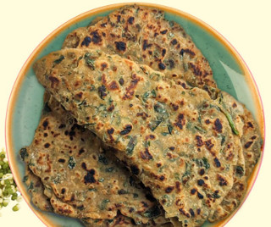
Credit: https://www.liveayurved.com/ayurveda_recipes/images/Green_Gram_&_Fenugreek_Chila.jpg
Ingredients:
Green gram sprouts – 200 gm (1 cup)
Chopped fenugreek leaves – 100 gm (1/2cup)
Ginger – a small piece
Bengal gram flour –10 gm (2 teaspoon)
Turmeric powder – 1-2 gm (¼ teaspoon)
Salt – to taste
Ghee /Oil – 5 ml (1 teaspoon)

Total quantity: 2-3 medium size chila

Method of Preparation :
- Take a mixer grinder and add the green gram sprouts and a small piece of ginger grind it smooth like batter consistency,
- Then add 1 cup of chopped fenugreek leaves, 2 teaspoon of Bengal gram flour and salt as per taste to the batter, mix it well and rest it for the 15 min.
- After that heat up the flat pan lightly grease it with oil. Pour a ladleful of batter onto the centre of tawa and spread it in a circular motion to form a thin, cook until the chila becomes crispy. And have it with any side dish of your choice.

14. Ardraka Paka (Barfi):

Ref:Traditional food recipes from Ayush systems of medicines
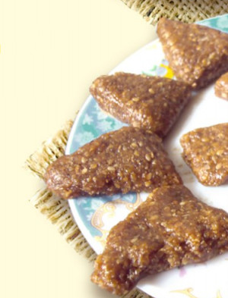
Credit:https://www.liveayurved.com/ayurveda_recipes/images/Ardraka_Paka.jpg
Ingredients :
Ginger – 250 gm (1and 1/4cup)
Jaggery – 250gm (1 and ¼ cup)
Ghee – 125gm (1/2 cup)
Dry ginger powder – 25gm (5 teaspoon)
Cumin – 25gm (5 teaspoon)
Black pepper – 25 gm (5 teaspoon)
Cardamom powder– 25gm (5 teaspoon)
Cinnamon powder – 25 gm (5 teaspoon)
Indian bay leaf powder – 25 gm (5 teaspoon)
Coriander powder – 25gm (5 teaspoon)
Sesame seeds – 5-10 gm (1-2easpoon)
Nagakesar – (if available) 25 gm

Total quantity – 20 small pieces

Method of preparation :
- Take a pan add jaggery, cook till a thick syrup is formed. Then add grated ginger, stir and cook for 5-7 min. on low flame.
- Add ghee and mix well, cook for another 5-10 min. now add the powder of all above ingredients and cook for another 5-10 min.
- If you want sesame seeds, then add it 2-3tsp. it is optional and spread the content on plate greased with ghee.
- Let it cool before cutting in pieces in any shape. When cooled, store in an air tight container. It remains for about a month.

15. Fresh Fenugreek stir fry(Methika) :
Ref :
- Shri Ksema Sarmakrut Ksemakutuhalam Classical Treatise on health care, Dietetics and Cookery – Culinary Science (Sanskrit Text with English Commentary) By Prof.(Dr.Gyanendra Pandey) 8/121
- Dietary Guidelines for Indians, ICMR-National Institute of Nutrition (2024)

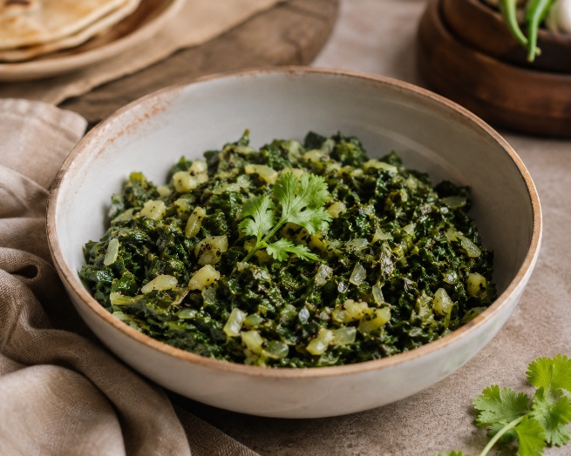
Image generated with use of AI

Ingredients :
Methi leaves – 75 – 100 gm (1/2 cup)
Hingu – 0.5 to 1 gm (a pinch)
Ghee – 5 ml (1 teaspoon)
Rock salt – to taste

Total quantity – one medium size bowl

Method of preparation :
- Take methi leaves and clean well with water
- Now boil the leaves in water up to 3-5min (until properly boiled) and squeeze it properly to make lump/mass.
- Take a clean pan and add ghee and heat it, then add hingu, boiled methi mass and rock salt as per taste and roast it properly.

16. Punjabi greens : P. No: 183
Ref :
- Morningstar A. Ayurvedic Cooking for All: Familiar Food Prepared with Ayurvedic Principles. 3rd reprint. New Delhi: Motilal Banarsidass Publishers Pvt. Ltd.; 2011. p. 183
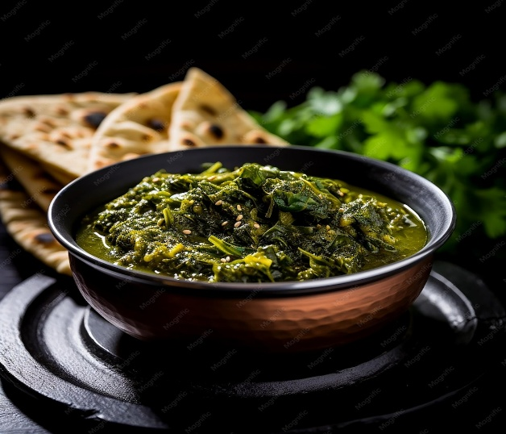
Image generated with use of AI
Ingredients:
Dark green leafy vegetable(any of your choice) – 125 gm(1/2 cup)
Ghee /Oil – 7 ml (1 and ½ teaspoon)
Cumin seeds – 1-2 gm (1/4 teaspoon)
Turmeric powder – 0.6 – 1gm (a pinch)
Hing – 0.5-1 gm ( a pinch)
Onion – 7-10 gm (2 teaspoon)
Garlic paste – 1-1.5 gm (¼ teaspoon)

Method of preparation :
- Wash the green leafy vegetable of your choice thoroughly with water, then chop.
- Take a pan add oil and heat it on medium flame then add cumin seeds, turmeric and hingu to it.
- Add garlic paste, chopped onion(optional) fry till the onion turns into the golden brown colour.
- After that add chopped green leafy vegetable and cook over medium heat until it is cooked properly and rock salt is an optional with proper quantity.

17. Brinjal fry :
Ref :
- Shri Ksema Sarmakrut Ksemakutuhalam Classical Treatise on health care, Dietetics and Cookery–Culinary Science (Sanskrit Text with English Commentary) By Prof.(Dr.Gyanendra Pandey)6/179-180
- Dietary Guidelines for Indians, ICMR- National Institute of Nutrition (2024)

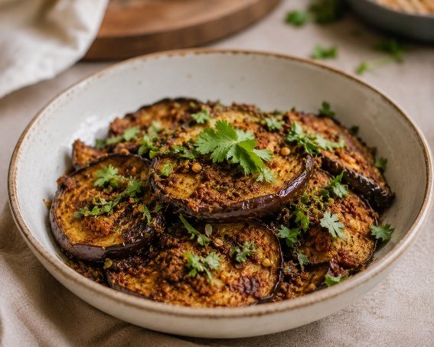
Image generated with use of AI

Ingredients :
Brinjal – 100-120 gm (1/2 cup)
Oil – 15-20 ml (3-4 teaspoon)
Lemon juice – 5-10 ml (1-2 teaspoon)
Hing – 2-3 gm (1/2 teaspoon)
Ginger paste – 3-4 gm (1 teaspoon)
Rock salt – 3-4gm (1 teaspoon)
Coriander leaves – 8-10 gm (2 teaspoon)

Total quantity – one medium size bowl

Method of preparation:
- Take brinjal wash it thoroughly and cut them into thin slices.
- Heat the oil in a pan, Cook sliced brinjal in medium flame, stir it occasionally.
- Fry until the brinjal becomes soft and crispy on edges after that add hingu, ginger paste and rock salt as per taste and cook another 2-3 min. then switch off the flame,
- Add lemon juice to it and mix it well
- Cover and leave it for 3-5min. and garnish with coriander leaves before serving it.

18. Parval fry (Patola preparation):
Ref :
- Shri Ksema Sarmakrut Ksemakutuhalam Classical Treatise on health care, Dietetics and Cookery – Culinary Science (Sanskrit Text with English Commentary) By Prof.(Dr.Gyanendra Pandey) 6/41
- Dietary Guidelines for Indians, ICMR- National Institute of Nutrition (2024)

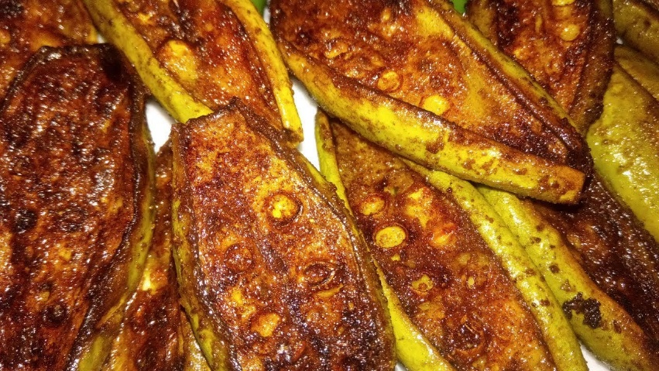
Credit:maxresdefault.jpg (1280×720)
Ingredients :
Pointed gourd – 10-20 gm
Ghee – 15-20 ml (3-4 teaspoon)
Hingu – 2-3gm (1/2 teaspoon)
Rock salt – 2-3 gm (1/2 teaspoon)

Total quantity – one medium size bowl

Method of preparation :
- Take a pointed gourd wash it thoroughly and cut them into thin slices.
- Heat the ghee in a pan. Fry sliced patola(pointed gourd) in medium flame, stirring occasionally.
- Then add hing, Rock salt and as well as other spices that you want for the taste with proper quantity and cook dry on moderate fire until it becomes soft
- Once it is evenly cooked switch off the flame, cover it for 3-5min.
- Serve the dish when it is hot to enjoy the flavour.

19. smoky Egg plant delight :
Ref :
- Gowans S. Food for Life: Ayurvedic Recipes. Chennai: Shanti Gowans; 2009. p. 163
- Dietary Guidelines for Indians, ICMR- National Institute of Nutrition (2024)

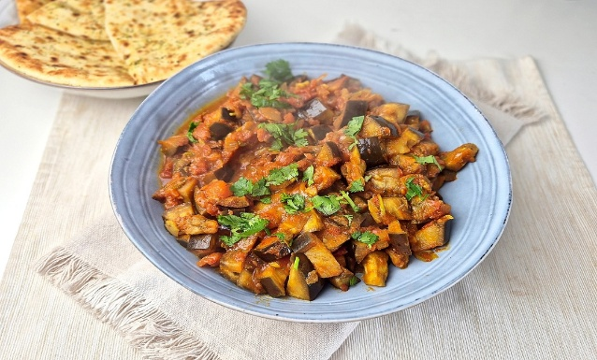
Credit:1000106598.jpg (1332×999)

Ingredients :
Egg plant – 100-120 gm (1/2 cup)
Mustard seeds – 2-3gm (½ teapoon)
Cumin seeds – 2-3 gm (1/2 teaspoon)
Curry leaves – 4-6 leaves
Turmeric powder – 2-3 gm (1/2 teaspoon)
Onion – 30-40 gm (¼ cup)
Oil – 10-15 ml (2-3 teaspoon)

Total quantity – one medium size bowl

Method of preparation:
- Wash and slice eggplant into small pieces, sprinkle with salt and wait until eggplant sweats. Wash off salt and dry.
- Heat oil in pan and pop the mustard seeds, follow with cumin seeds, curry leaves and then onion and stir.
- Once the onion become transparent add the turmeric. Add eggplant closed the lid until it cook soft then add salt as per taste. Have it as a side dish.

20. Smoky Golden delight (Pumpkin with almonds):
Ref :
- Gowans S. Food for Life: Ayurvedic Recipes. Chennai: Shanti Gowans; 2009. p. 173
- Dietary Guidelines for Indians, ICMR- National Institute of Nutrition (2024)

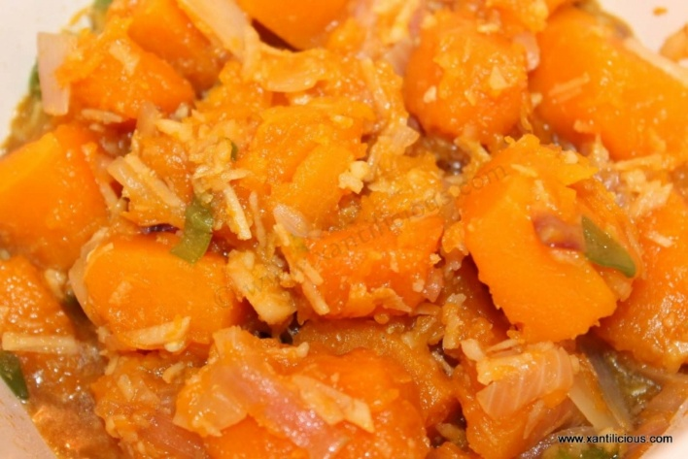
Credit:IMG_7981123.jpg (1200×801)

Ingredients:
Sliced pumpkin – 100-120 gm (½ cup)
Sliced almonds – 25-30 gm (2 tablespoon)
Rock salt – to taste
Mustard seeds – 2-3 gm (1/2 teaspoon)
Cumin seeds – 2-3 gm (1/2 teaspoon)
Curry leaves – 4-5 leaves
Chopped onion – 30-40 gm (1/4 cup)
Turmeric – 2-3 gm (½ teaspoon)
Ghee – 5 gm (1 teaspoon)

Total quantity: one medium size bowl

Method of preparation :
- Cut the pumpkin into small sized cubes and cook them on steam.
- Take pan add ghee heat it after that pop the mustard seeds then add cumin seeds, curry leaves and Chopped onion fry till the onion turns to golden colour.
- Take another pan and fry the sliced almonds till it turns to golden brown.
- Then add Steamed pumpkin sliced to the pan fry it well. Then add roasted almonds to it and add turmeric powder and salt as per the taste.
- Mix all together perfectly and close the lid for 3-4 min. then switch off the flame and have it.

21. Sweet Aloo Saute (Pumkin and Sweet potato)P. No: 177
Ref :
- Gowans S. Food for Life: Ayurvedic Recipes. Chennai: Shanti Gowans; 2009. p. 173
- Dietary Guidelines for Indians, ICMR- National Institute of Nutrition (2024)

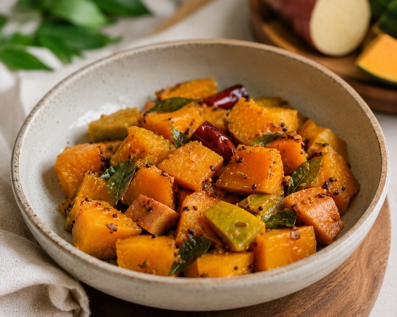
Image generated with use of AI

Ingredients :
Chopped Pumpkin – 100 gm (1/2 cup)
Chopped sweet potato – 75 gm (5 tablespoon)
Mustard seeds – 2 gm (1/4 teaspoon)
Cumin seeds – 2 gm (¼ teaspoon)
Curry leaves – 6-8 leaves
Chopped onion – 20 gm (4 teaspoon)
Ginger paste – 3 gm (1/2 teaspoon)
Turmeric powder – 0.5 gm (a pinch)

Total quantity: one medium size bowl

Method of preparation :
- Steam the chopped pumpkin and chopped sweet potato until they become soft.
- Take a pan add ghee heat it on medium flame.
- Then add mustard seeds, cumin seeds, curry leaves, chopped onion, ginger paste and turmeric powder fry them properly.
- Add steamed vegetables to the pan add rock salt as per taste mix it all together properly and closed the lid for 2-3min. then have it.

22. Gooseberry stir fry (pickle):

Ref:Traditional food recipes from Ayush systems of medicine

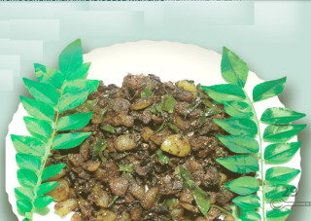
Credit:Gooseberry_Stir_Fry.jpg (320×227)

Ingredients :
Indian gooseberry (amla) – 170 gm (7/8 cup)
Sesame oil – 10 ml (2 teaspoon)
Curry leaves – 8-10 leaves
Black pepper powder – 2 gm (1/4 teaspoon)
Turmeric powder – 2 gm (¼ teaspoon)
Salt – to tastes

Total quantity – medium size ½ cup

Method of preparation :
- Wash the Amla thoroughly and dry well, cut and remove seeds.
- Take a pan add sesame oil and heat it on medium flame add amla pieces fry well.
- Add curry leaves, pepper powder, turmeric powder, salt, hing and mix well. Then have it as side dish.

23. Coconut Laddu(Narikela modaka) :
Ref :
- Shri Ksema Sarmakrut Ksemakutuhalam Classical Treatise on health care, Dietetics and Cookery – Culinary Science (Sanskrit Text with English Commentary) By Prof.(Dr.Gyanendra Pandey) 10/54
- Dietary Guidelines for Indians, ICMR- National Institute of Nutrition (2024)

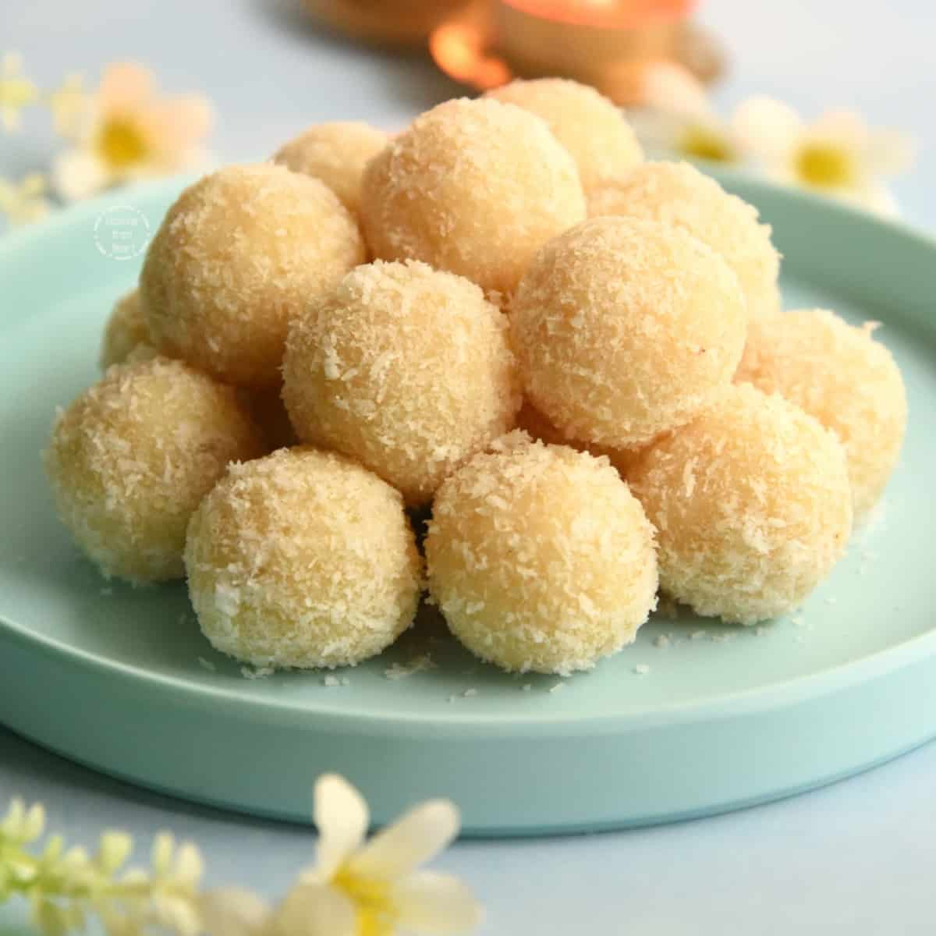
Credit:Coconut-Ladoo-Recipe.jpg (1200×1200)

Ingredients :
Graded coconut – 40-50 gm (1/4 cup)
Milk – 30-40 ml (as needed for proper cooking)
Ghee – 10-15 ml (2-3 teaspoon)
Rock sugar powder – 15-20 gm (3-4 teaspoon)
Cardamom powder – 2-3 gm (1/2 teaspoon)
Dry ginger powder – 2-3s gm (1/2 teaspoon)

Total quantity – 3-4 medium size laddoos

Method of preparation :
- Take a cup of graded coconut in a pan and add milk and cook well
- Take required quantity of ghee in another pan and then this cooked material is roasted in ghee properly.
- Take another pan for the preparation of sugar syrup, take sugar as per desired quantity of sweetness and add proper quantity of water now boil it until it forms proper consistency for the binding purpose
- Then add roasted graded coconut into sugar syrup and also add cardamom powder and dry ginger powder as required quantity and make small laddus out of it.
- It can be stored till 5 to 7 days
- Enjoy it like a snack and when required

Contraindications:
- Diabetes
- Overweight / Obesity
- Lactose intolerance
- Sedentary life style with poor metabolism

24. Sweet Coconut momo (Bhaimi) :
Ref :
- Shri Ksema Sarmakrut Ksemakutuhalam Classical Treatise on health care, Dietetics and Cookery – Culinary Science (Sanskrit Text with English Commentary) By Prof.(Dr.Gyanendra Pandey) 10/86
- Dietary Guidelines for Indians, ICMR- National Institute of Nutrition (2024)
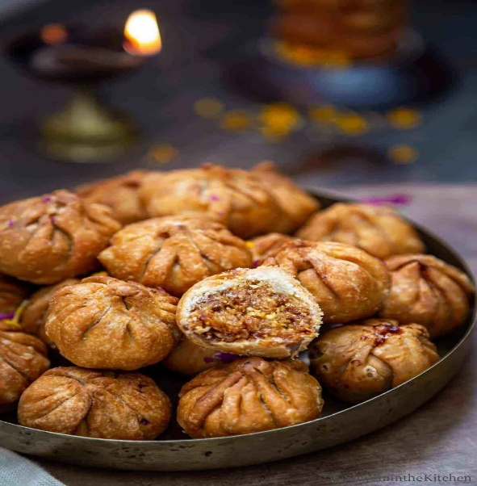
Credit:38ac62282d268b194cc7dc0f29b08bec.jpg (1200×1800)

Ingredients :
Wheat flour – 50-60 gm (1/4 cup)
Ghee – as needed for deep frying
Graded coconut – 30-40 gm (1/4 cup)
Dry grapes – 10 gm (2 teaspoon)
Chopped Kharjura – 15 gm (3 teaspoon)
Rock sugar powder – 10-15 gm (2-3teaspoon)
Aromatic powder – 2-3 gm (1/2 teaspoon)
(Cardamom – 3-4, Clove – 2-3, Pepper – 2-3, Cinnamon – 2-3inch, Dry ginger – 2-3 inch, Edible camphor (pacha karpooram) – 2-3 small crystals – make all them into fine powder)

Total quantity – 2-3 medium size momo

Method of preparation :
- Preparation of dough – Take a cup of wheat flour add ghee and add required amount of water kneaded well to make it soft dough.
- Preparation of stuff – Take ghee in pan, heat it and add graded coconut, dry grapes, chopped kharjura, required quantity of sugar powder then add aromatic powder roast well in a medium flame and make it as paste for the stuffing purpose.
- Divide the dough into small balls, roll each ball into a thin circular wrapper.
- Place filling in the centres. Fold and pleat the edges to seal it properly.
- Then fry deeply in the ghee with mild fire until it turns into golden brown.

Contraindications:
- Diabetes
- Overweight / Obesity
- Sedentary life style with poor metabolism

25. Urad Amrut Laddu(Masha ladduka):

Ref :
- Shri Ksema Sarmakrut Ksemakutuhalam Classical Treatise on health care, Dietetics and Cookery – Culinary Science (Sanskrit Text with English Commentary) By Prof.(Dr.Gyanendra Pandey) 10/29-30
- Dietary Guidelines for Indians, ICMR- National Institute of Nutrition (2024)

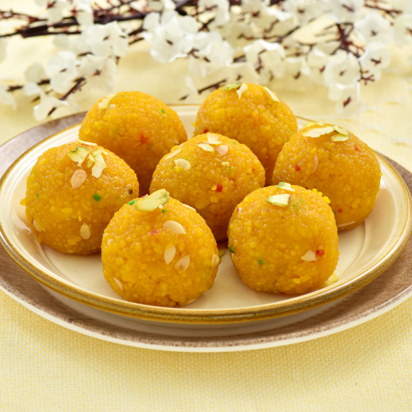
Credit:3-7.png (1080×1080)
Ingredients :
De-husked black gram – 30-50 gm (1/4 cup)
Ghee – for deep frying
Dry fruits (Choice)
Rock sugar powder – 20-30 gm (to taste)
Aromatic powder – 2-3 gm (½ teaspoon)
(Cardamom -3- 4, Clove – 2-3, Pepper – 2-3, Cinnamon – 2-3inch, Dry ginger – 2-3inch, Edible camphor (pacha karpooram) – 2-3 small crystals – make all them into fine powder)

Total quantity – 3-4 medium size laddoos

Method of preparation :
Batter preparation:
Soak a de-husked black gram in water for 4-6hrs. after that drain the water, grind with small quantity of fresh water added gradually. Grind until the batter is soft enough and is having pouring consistency.

Boondi preparation :
Heat the ghee in a deep pan, hold a boondi ladle/Perforated spoon over the ghee and pour a little batter onto the ladle and gently tap it so that small droplets fall into the ghee and deep fry them until cooked but not crispy. Remove and drain excess oil.
Sugar syrup preparation :
In a pan add sugar and water heat until the sugar dissolves and forms into syrup consistency. Add aromatic powder to it and mix it well.
Laddu preparation :
Now add the ghee fried boondi to the hot sugar syrup mix well so that the boondi absorbs the syrup and also add ghee roasted dry fruits to it. once it attained a desirable consistency make laddus out of it by taking a desirable amount, if the mixture is dry, sprinkle a little warm syrup /water to make good consistency.

Contraindications:
- Diabetes
- Overweight / Obesity
- Sedentary life style with poor metabolism

26. wheat balls (Godhuma laddu) :

Ref:
- Dietary Guidelines for Indians, ICMR- National Institute of Nutrition (2024)

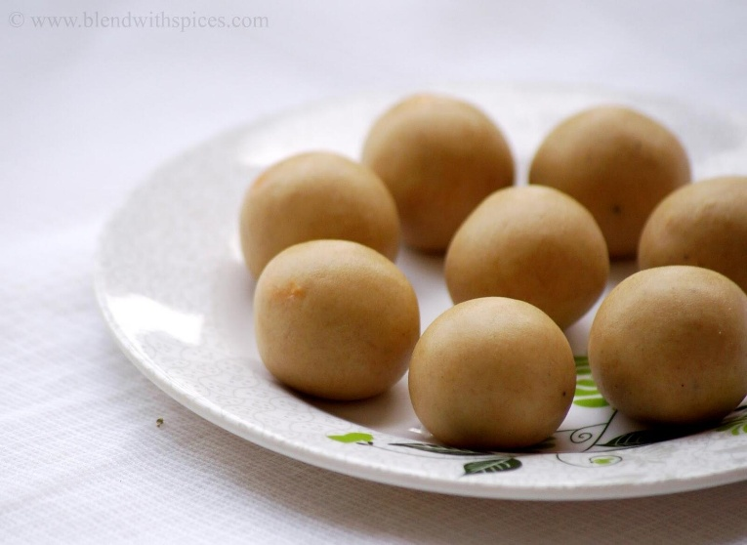
Credit:aatekipinni.jpg (1600×1166)

Ingredients :
Wheat flour – 40-60 gm (1/4 cup)
Ghee – 15-20 gm (3-4 teaspoon)
Jaggery – 15-20 gm (to taste)
Cardamom powder – 2-3 gm (1/2 teaspoon)
Dry ginger powder – 2-3 gm (1/2 teaspoon)

Total quantity – 3-4 medium size laddoos

Method of preparation :
- Take a ghee in a pan and once the ghee becomes hot add wheat flour and roast well in a medium flame.
- Take another pan add jaggery as desired quantity of sweetness and add a sufficient quantity of water and boil it to make a proper consistency of jaggery syrup for binding purpose.
- Once the syrup is prepared turn off the flame then slowly add roasted wheat flour stir continuously to avoid the lump once it mixes well then add cardamom powder and dry ginger powder mix it well.
- Once it attained a desirable consistency, make laddus out of it by taking a desirable amount, if the mixture is dry, then add a desired quantity of ghee or sprinkle a little warm syrup /water to make good consistency.

Contraindications:
- Diabetes
- Overweight / Obesity
- Sedentary life style with poor metabolism

27. Jamun(Manda) :

Ref :
- Bhojana Kutuhala Siddhannaprakarana (Bhaksha prakarana), p.62
- Dietary Guidelines for Indians, ICMR- National Institute of Nutrition (2024)

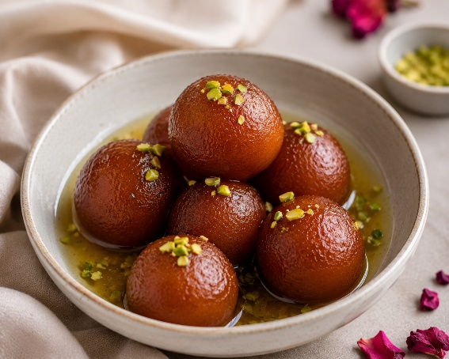
Image generated with use of AI

Ingredients :
Refined wheat flour – 40-50 gm (1/4 cup)
Water – as needed
Ghee – as needed
Rock sugar – to taste
Aromatic powder – 2-3gm (1/2tsp)
(Cardamom - 4, Clove – 2, Pepper – 2, Cinnamon – 2inch, Dry ginger – 2 inch, Edible camphor (pacha karpooram) – 2 small crystals – make all them into fine powder.)

Total quantity – 3-4 medium size manda

Method of Preparation :
Take a cup of refined wheat flour in a mixing bowl add 2-3tsp. of melted ghee mix well, add water gradually and knead gently to make a soft and smooth dough.
Then divide the dough into small portions and make them into smooth, crack free balls.
Take a pan and heat the ghee on medium flame then slowly add the balls into ghee, fry the balls slowly until they turn golden brown on all sides then remove the balls and drain excess ghee.
Take another pan and prepare the sugar syrup with 1tsp. of aromatic powder, Once the syrup prepared turn off the flame
Once these balls cools to moderate temperature then transfer the balls into the warm sugar syrup.
Allow them to soak for 2-3 hrs so that they absorb the syrup well.
Enjoy it.

Contraindications:
- Diabetes
- Overweight / Obesity
- Sedentary life style with poor metabolism

28. Golden Bliss Laddu(Samita modak) :

Ref :
- Bhojana Kutuhala Siddhannaprakarana (Bhaksha prakarana), p.70
- Dietary Guidelines for Indians, ICMR- National Institute of Nutrition (2024)

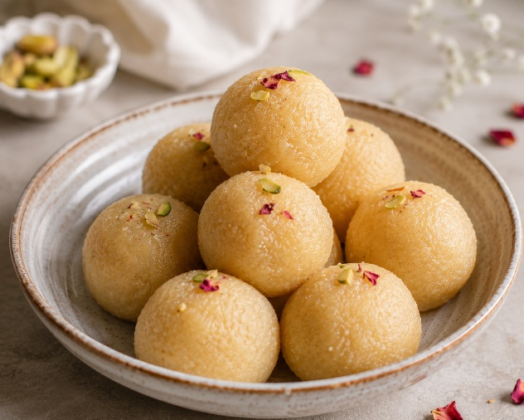
Image generated with use of AI

Ingredients :
Refined wheat flour – 50-70 gm (1/4 cup)
Ghee – required quantity
Rock sugar powder – 15-20 gm (to taste)
Aromatic powder – 2-3 gm (1/4 teaspoon)
(Cardamom – 3-4, Clove – 2-3, Pepper – 2-3, Cinnamon – 2-3inch, Dry ginger – 2-3 inch, Edible camphor (pacha karpooram) – 2-3 small crystals – make all them into fine powder.)

Total quantity: 3-4medium size laddoo

Method of Preparation :
Take refined wheat flour in a mixing bowl add pinch of rock salt (if desired) and ghee mix well. Gradually add water and knead into firm dough. Cover the dough and allow it to rest for 15-20 min.
Divide the dough into equal portions and make a medium sized round ball. Place these balls over the coal embers or a wire rack above the charcoal
OR Bake in a preheated oven at 180*C for 25-30 min.
OR use Air fryer,
OR use preheated pressure cooker for 10 min. with layer of salt or sand at the bottom of a cooker. Place the wheat balls on a rack and cook on low flame for 30-40min. turning occasionally.
OR use thick bottomed pan over low flame gas stove turning occasionally, once partially cooked, roast them directly over a low flame for a few min. to achieve golden brown colour.
Remove the cooked balls from heat and allow them to cool.
Take a mixing bowl and make these cooked balls into powder then add required quantity of rock sugar powder and 1tsp. of aromatic powder then add required quantity of ghee to make laddus.

Contraindications:
- Diabetes
- Overweight / Obesity
- Sedentary life style with poor metabolism

29. Kharjur Laddoo:

Ref : Traditional food recipes from Ayush system of medicine

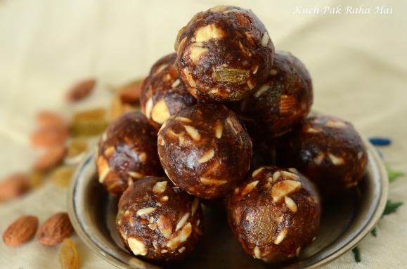
Credit:https://www.kuchpakrahahai.in/wp-content/uploads/2017/06/DSC_0367.jpg

Ingredients :
Kharjur (dates) – 250gm
Cashew – 10
Almonds – 10
Grated dry coconut – 100gm

Total quantity – 10-12 laddoos

Method of Preparation :
Separate seeds from the dates and cut in small pieces. Cut the cashew and almonds also in small pieces and slightly roast in the pan with 2 spoons of ghee.
After that mix the kharjur pieces in pan and make small sized laddoos and roll it over the grated coconut.
Roasted sesame seeds may be used instead of grated coconut.

30. Sweet Potato Salad : P. No: 73

Ref :
- Morningstar A. Ayurvedic Cooking for All: Familiar Food Prepared with Ayurvedic Principles. 3rd reprint. New Delhi: Motilal Banarsidass Publishers Pvt. Ltd.; 2011. p. 73
- Dietary Guidelines for Indians, ICMR- National Institute of Nutrition (2024)

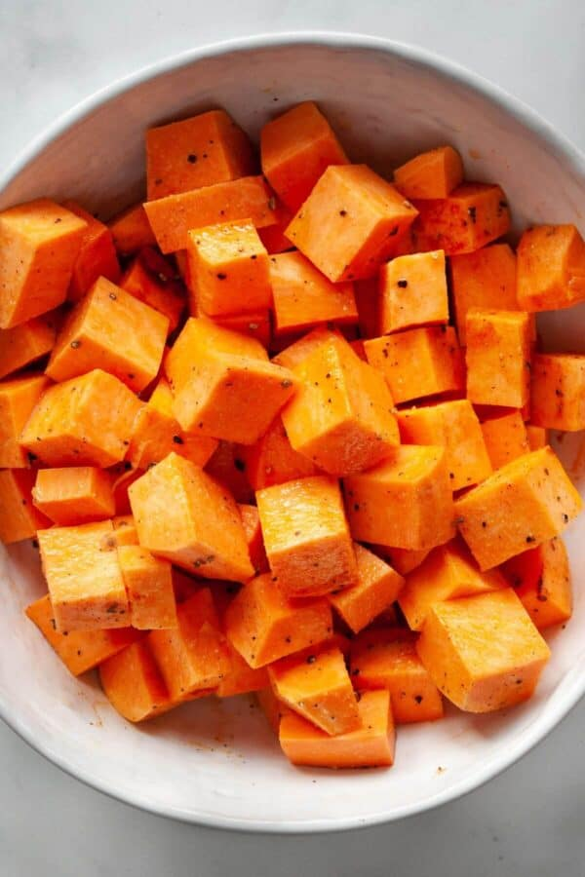
Credit : Image generated with the help of AI

Ingredients :
Sweet potato – 150 gm (3/4 cup)
Fresh ginger paste – 4 gm (1teaspoon)
Fresh lemon juice – 15 ml (3teaspoon)
Honey – 2.5 ml (1/2 teaspoon)
Sesame oil – 8-9 ml (2teaspoon)
Rock salt – 1 gm (to taste)

Total quantity: ½ medium size cup

Method of preparation :
- Boil the sweet potato in water then take off the outer layer of the sweet potato
- Cut the boiled potato in medium size and square shape
- Take a mixing bowl add cut sweet potato and add above mentioned all the ingredients in sufficient quantity, add heated sesame oil to it.
- Toss well with dressing and serve warm or cool.

31. Sweet potato biscuits : P. No: 169

Ref :
- Morningstar A. Ayurvedic Cooking for All: Familiar Food Prepared with Ayurvedic Principles. 3rd reprint. New Delhi: Motilal Banarsidass Publishers Pvt. Ltd.; 2011. p. 73

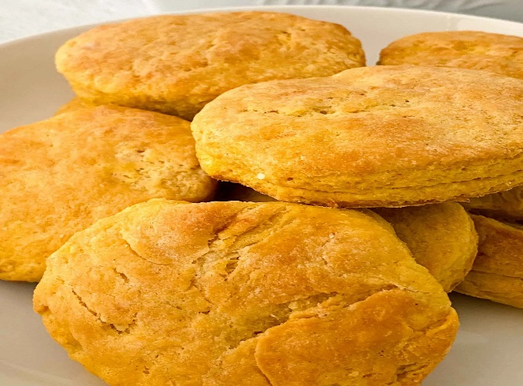
Credit:The-Best-Sweet-Potato-Biscuits-Recipe-01.jpg.webp (1536×2048)

Ingredients
Wheat flour / Barley flour – 240 gm (1 cup + 3 tablespoon)
Salt – 5 gm (1teaspoon)
Baking powder – 10 gm (2 teaspoon)
Baking soda – 1.2 gm (2 pinch)
Butter / Ghee – 56 gm (1/4 cup)
Sweet potato – 150 gm (3/4 cup)
Lemon Juice – 30 ml (2 tablespoon)
Cow’s milk – 60-70 ml (1/4 cup)

Total quantity : 24-28 biscuits

Method of preparation :
- Take a mixing bowl add wheat flour / Barely flour, salt, baking powder and baking soda mix all together.
- Then add butter or ghee to the mixing bowl and mix it well.
- Take one medium size boiled, peel and mashed sweet potato to the mixing bowl and add lemon juice, cow’s milk as required.
- Mix all together properly to make a soft dough for that if it needs any extra flour or milk then add it as required.
- Cover the dough and rest it for 15 min, preheat the oven to 450*F
- Roll the dough gently and cut it into biscuit shapes using a cutter or knife.
- Place the biscuits on a greased baking tray.
- Bake in a preheated oven until the biscuits turns light golden brown.
- Remove from the oven and allow them to cool completely.
- Store in an airtight container.

32. Banana apricot Muffins: P. No: 174

Ref :
- Morningstar A. Ayurvedic Cooking for All: Familiar Food Prepared with Ayurvedic Principles. 3rd reprint. New Delhi: Motilal Banarsidass Publishers Pvt. Ltd.; 2011. p. 174

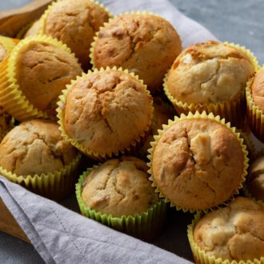
Credit:https://www.cookingnook.com/wp-content/uploads/banana-muffins-apricots-750-330x330.jpg

Ingredients :
Dried organic apricot – 9 (72 gm)
Ripe banana – 2 (240 gm)
Almond oil – 42 ml (1/4 cup)
Maple syrup / Sugar syrup – 80 ml (to taste)
Wheat flour / Barel flour – 150 gm (3/4 cup)
Baking powder – 5 gm (1 teaspoon)
Rock salt – 3 gm (to taste)

Total quantity : 12 muffins
Method of preparation :
- Soak the apricot in hot water up to 15 min. then finely chop.
- Take a mixing bowl and mash the 2 ripe bananas perfectly then add 3 tsp. of almond oil and ¼ tsp. of maple syrup mix all together
- In the mixing bowl add 1 cup. of wheat flour / barely flour, 1 tsp. of baking powder and ½ tsp. of salt to it then also add chopped apricot and make this mixture as thick batter by adding required quantity of water.
- Take a lightly oiled muffin tin and add batter to this, bake for 25 min. in the pre heated oven to 350*F.
- Cook until a toothpick inserted into the centre of a muffin comes out clearly.
- Then enjoy it after cooling.

33. Almond nut crust : P. No: 257

Ref :
- Morningstar A. Ayurvedic Cooking for All: Familiar Food Prepared with Ayurvedic Principles. 3rd reprint. New Delhi: Motilal Banarsidass Publishers Pvt. Ltd.; 2011. p. 257

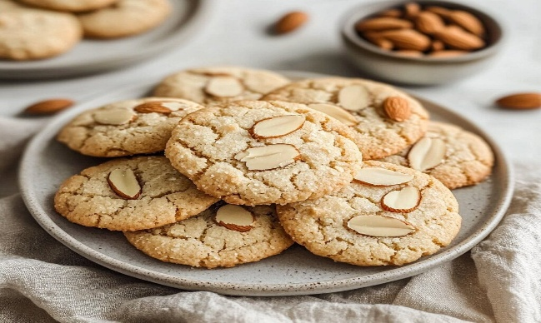
Credit:https://specialyrecipes.com/wp-content/uploads/2025/07/Homemade-Almond-Cookies-on-Ceramic-Plate-with-Sliced-Almond-Topping.jpg

Ingredients :
Finely grounded raw almonds – 14 gm (1 tablespoon)
Brown sugar – 36 gm (to taste)
Wheat flour / barely flour – 150 gm (3/4 cup)
Rock salt – to taste
Cold butter – 56 gm (¼ cup)
Cold water – 60 ml (as needed)

Total quantity: 18-20 crust

Method of preparation :
- Take a mixing bowl add wheat flour or barely flour, raw almond powder, powdered sugar and salt as per taste mix all together.
- Then add butter and required quantity of cold water to make a dough.
- Cover the dough and rest it for 15 min. then preheat the oven to 375*F
- Roll the dough gently and cut it into biscuit shapes using a cutter or knife.
- Place the biscuits on a greased baking tray.
- Bake in a preheated oven up to 15 min. or till the biscuits turns light golden brown.
- Remove from the oven and allow them to cool completely.
- Store in an airtight container.

34. IVY’S Coconut Sesame rice : P.No : 202
Ref :
- Morningstar A. Ayurvedic Cooking for All: Familiar Food Prepared with Ayurvedic Principles. 3rd reprint. New Delhi: Motilal Banarsidass Publishers Pvt. Ltd.; 2011. p. 202

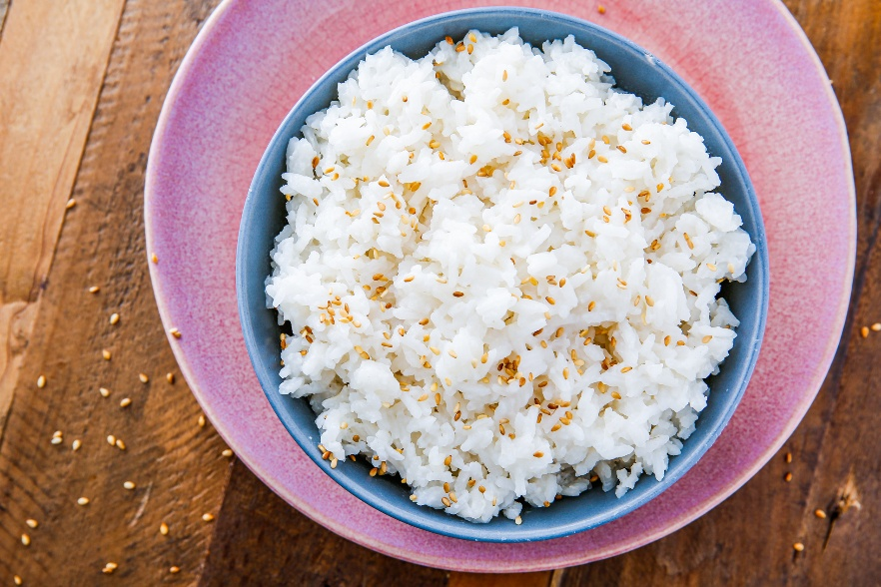
Credit:https://hips.hearstapps.com/hmg-prod/images/20190628-delish-coconut-rice-ehg-341-horizontal-1562794851.png

Ingredients:
Rice – 50 gm (1/4 cup)
Ghee – 8-10 gm (2 teaspoon)
Rock salt – 1.5 gm (to taste)
Sesame seeds – 10 gm (2 teaspoon)
Desiccated coconut – 5 gm (1 teaspoon)

Total quantity : 1 medium size bowl

Method of preparation :
- Cook rice well with water, ghee and rock salt as per the taste.
- Take pan add ghee heat it on medium flame then add sesame seeds and desiccated coconut and fry until they turns to slightly darken.
- Then add cooked rice to this pan and mix all together properly and garnish with coriander leaves and have it.

35. Steamed Rice Cake (Indarika Idli)
Ref :
- Ayurveda Mahodadhi, Pakvannavarga (16th varga), Shloka-11
- Dietary Guidelines for Indians, ICMR- National Institute of Nutrition (2024)

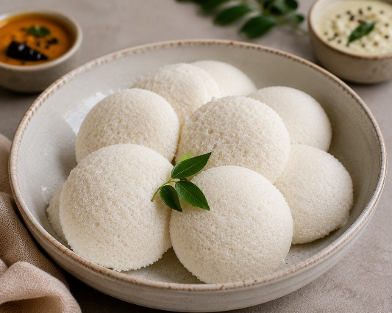
Image generated with use of AI
Ingredients :
Rice flour – 40-50 gm (1/4 cup)
Black gram flour – 20-30 gm (2 tablespoon)
Rock salt – to taste
Water – 60-70 ml (as needed for to make a thick batter)

Method of preparation :
- Take both the flour and add sufficient quantity of water and mix thoroughly to prepare a smooth batter not too thick or thin and keep overnight.
- Next morning add required quantity of rock salt to the fermented batter and mix well.
- Take a batter in an idly maker or steamer and subject to steaming until it is properly cooked.

36. Karpura Crispy Sticks (Karpuranalika) :
Ref :
- Bhavaprakash Nighantu, Kritanna varga, 12/117-118
- Dietary Guidelines for Indians, ICMR- National Institute of Nutrition (2024)

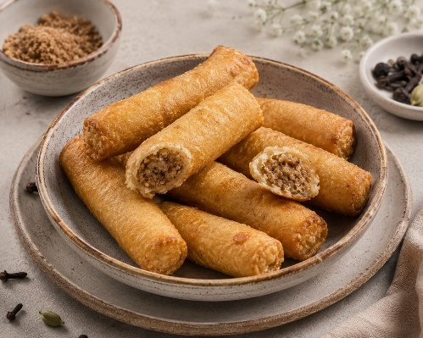
Image generated with use of AI
Ingredients :
Wheat flour/Samita – 50-60 gm (1/4 cup)
Clove powder – 1-2 gm (1/4 teaspoon)
Edible camphor (Karpura) – a pinch
Pepper powder – 1-2 gm (1/4 teaspoon)
Ghee– for deep fry
Water– 25-30 ml (as needed)
Rock sugar powder – 15-20 gm (to taste)

Method of preparation :
- Take a wheat flour / Samita in to a mixing bowl then add adequate quantity of water and ghee to knead it into a smooth dough.
- Shape the dough into small, elongated, tubular forms (3-5cm).
- For the preparation of filling, powder the ingredients like clove, pepper, Karpoor and rock sugar and mix together,
- Carefully stuff the little amount mixture inside the tubes, seal both ends securely by gently pressing the both edges and deep fry the filled tubes in ghee until they become golden and crispy.

37. stuffed fried cottage cheese dumplings (Dugdha Kupika)

Ref :
- Bhavaprakash Nighantu 12/132-135
- Dietary Guidelines for Indians, ICMR- National Institute of Nutrition (2024)

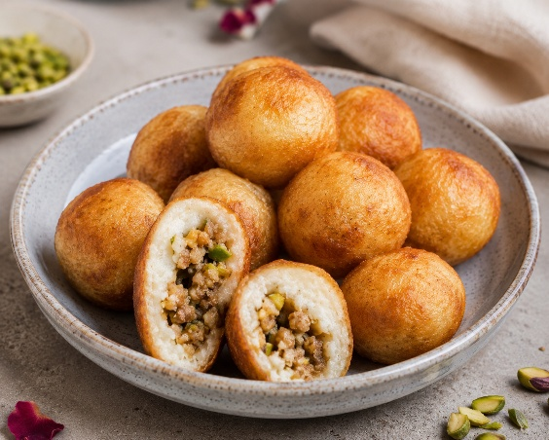
Image created with use of AI

Ingredients :
Cow’s milk – 500 ml
Ghee – 150 gm (3/4 cup)
Rock sugar – 20 gm (to taste)
Rice flour – 10 gm (2 teaspoon)
Edible camphor (Karpur) – a pinch

Total quantity: 3-4 stuffed fried cottage cheese dumplings (1serving)

Method of preparation :
Prepare Chena (Cottage cheese) :
- Boil 500 ml cow’s milk
- Add 10 ml lemon juice gradually while stirring until the milk curdles
- Strain through a muslin cloth and wash with clean water to remove sourness
- Hang for 20-30 min. to drain excess water.

Prepare the Dough :
- Transfer the prepared chena to a bowl.
- Add 10 gm rice flour
- Knead for 8-10 min. until a smooth, crack-free dough is obtained.

Shape the Dumplings :

- Divide the dough into 3-4 equal portions (about 25-30gm each)
- Roll into smooth balls.

First frying :
- Heat ghee over medium flame
- Deep-fry the balls until light golden brown
- Remove and allow them to cool slightly

Stuffing :
- Make a small cavity in the centre of each fried ball.
- Fill with a small amount of the reserved chena
- Seal the opening carefully using a little dough

Second frying :
- Fry the filled dumplings again until golden brown and fully cooked
- Remove and drain excess ghee

Sugar syrup :
- Dissolve 20 gm sugar in 40 ml water
- Boil until a 1-2 thread consistency is reached
- Add a tiny pinch of edible camphor

Final step :
- Immerse the fried dumplings in the warm sugar syrup for 10-15 min. and serve warm.

38. Barley Savory Discs (Kulmasha) :
Ref :
- Kaiyadeva Nighantu, 5/161-163, p.no: 426
- Dietary Guidelines for Indians, ICMR- National Institute of Nutrition (2024)

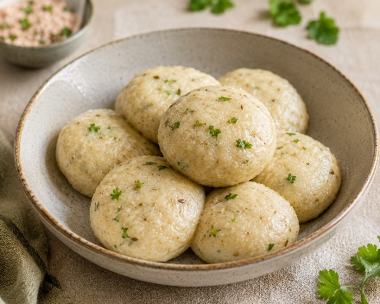
Image created with the use of AI
Ingredients :
Barley flour – 50-60 gm (1/4cup)
Hot water – 35-40 ml (as needed)
Rock salt – 1.5 gm (to taste)
Mustard oil – 5-10 ml (2 teaspoon)

Total quantity – 2 medium size barley savory discs

Method of preparation :
- Take barley flour in a mixing bowl, add required amount of rock salt and mustard oil. Gradually add sufficient hot water and knead well to form a smooth dough.
- Shape the dough into small, round discs (2-3 inches) and steam them until fully cooked.
- Once done, remove from heat.

39. Sweet Vermicelli balls (Sevika Modaka)
Ref :
- Bhavaprakash Nighantu, 12/126
- Dietary Guidelines for Indians, ICMR- National Institute of Nutrition (2024)

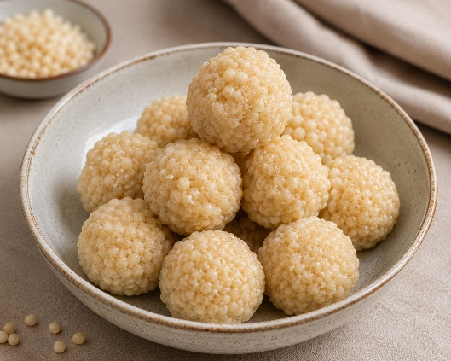
Image created with the use of AI
Ingredients :
Samita (Fine wheat flour) – 50-60 gm (1/4 cup)
Ghee – for deep frying
Rock sugar – 20-30 gm (to taste)

Total quantity – one serving

Method of preparation :
- Take a mixing bowl add flour and ghee mix thoroughly and add sufficient water to prepare a smooth dough.
- Heat the ghee in a deep pan, hold a boondi ladle/Perforated spoon over the ghee and pour a little batter onto the ladle and gently tap it so that small droplets fall into the ghee and deep frying them until crispy and golden.
- Once fried, immerse them in sugar syrup (one thread consistency) for proper absorption.
- Once soaked, remove the strands from sugar syrup and prepare small balls/ modaka as desired.

Contraindications:
- Diabetes
- Overweight / Obesity
- Sedentary life style with poor metabolism

40. milky wheat balls (Dravaka Modaka)
Ref:
- BhojanaKutuhala,Siddhannaprakarana (Bhakshyavishesha)p.no:81
- Dietary Guidelines for Indians, ICMR- National Institute of Nutrition (2024)

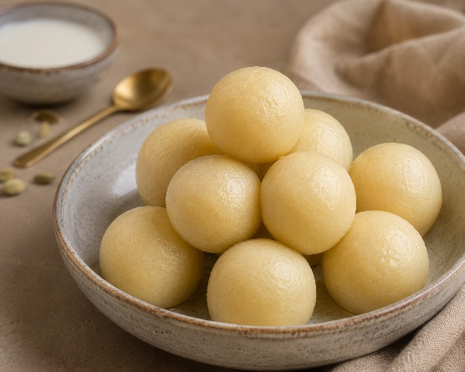
Image created with the use of AI
Ingredients :
Samita / Fine wheat flour – 50 gm (1/4 cup)
Rock sugar – 50 gm (1/4 cup)
Ghee – 10 gm (2 teaspoon)
Dugdha – 100 ml (1/2 cup)

Total quantity: 3-4 medium size balls

Method of preparation :
- Take flour milk and ghee, mix together to prepare thin batter.
- Cook the batter over low heat, once half cooked add the ghee
- And continue cooking until it reaches thicker consistency.
- Remove from the fire, place the mixture in a cool place and add an equal amount of sugar, mix thoroughly, and prepare small balls.

Contraindications:
- Diabetes
- Overweight / Obesity
- Lactose intolerance
- Sedentary life style with poor metabolism

41. Processed Wheat balls (Samita Modaka)

Ref:
- Bhojana Kutuhala, Siddhannaprakarana, (Bhakshyavishesha) p.no:81
- Dietary Guidelines for Indians, ICMR- National Institute of Nutrition (2024)

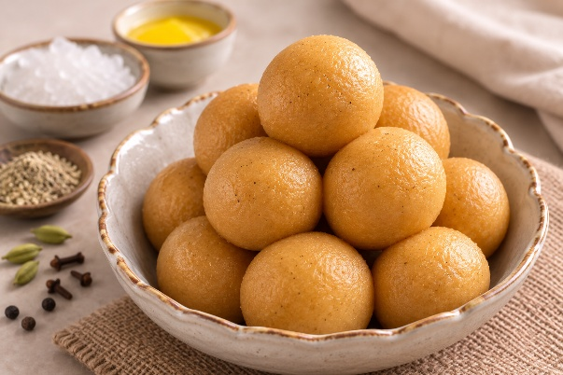
Image created with use of AI
Ingredients :
Samita (Fine wheat flour) – 50-60 gm (1/4 cup)
Ghee – 30-40 gm (as needed)
Rock sugar – 20-30 gm (to taste)
Clove – 1-2 gm (1/4 teaspoon)
Pepper – 1-2 gm (1/4 teaspoon)
Cardamom – 1-2 gm (1/4 teaspoon)

Total quantity: 3-4 medium size balls

Method of preparation :
- Fry Samita flour in ghee until it changes colour and allow it to cool
- Add required quantity of rock sugar along with powder of cardamom, clove and pepper.
- Mix thoroughly and prepare small balls

Contraindications:
- Diabetes
- Overweight / Obesity
- Sedentary life style with poor metabolism

42. Camphor sweet vermicelli balls(Chitta modaka)
Ref :
- Shri Ksema Sarmakrut Ksemakutuhalam Classical Treatise on health care, Dietetics and Cookery – Culinary Science (Sanskrit Text with English Commentary) By Prof.(Dr.Gyanendra Pandey) 10/21-23
- Dietary Guidelines for Indians, ICMR- National Institute of Nutrition (2024)

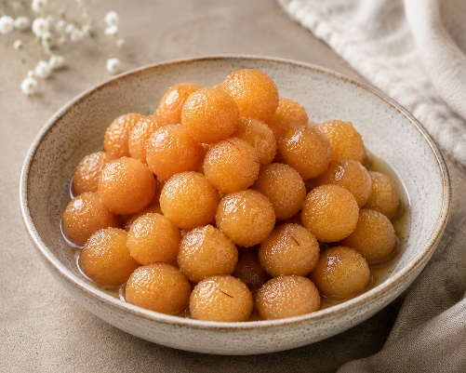
Image created with the use of AI
Ingredients :
Wheat flour – 50 gm (1/4 teaspoon)
Rock sugar – 25 gm (to taste)
Ghee – 150 gm (3/4 cup)
Camphor (Karpura) – a pinch

Total quantity: 3-4 medium size balls

Method of preparation :
- Take a mixing bowl add Wheat flour and ghee, mix thoroughly by adding sufficient amount of water to prepare a smooth dough.
- Heat the ghee in a deep pan, hold a boondi ladle/Perforated spoon over the ghee and pour a little batter onto the ladle and gently tap it so that small droplets fall into the ghee and deep frying them until crispy and golden.
- Once fried, immerse them in sugar syrup (one thread consistency) for proper absorption.
- Once soaked, remove the strands from sugar syrup and add edible camphor prepare small balls/ modaka as desired.

Contraindications:
- Diabetes
- Overweight / Obesity
- Sedentary life style with poor metabolism

43. Gooseberry fruit preserve (Amalaki Murabba)

Ref :
- Ayurveda sara Samgraha, Avaleha – paka prakaran, p, no:532
- Rasa Tantrasara Evum Siddha Prayoga Samgraha, part 1, p.no: 405
- Dietary Guidelines for Indians, ICMR- National Institute of Nutrition (2024)

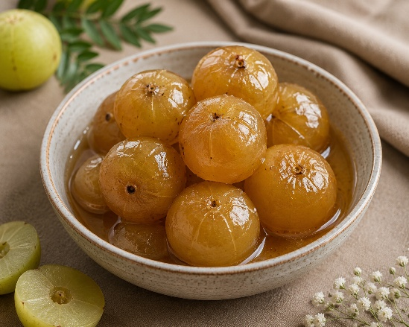
Image created with the use of AI
Ingredients :
Fresh amla – 100 gm
Sugar – 200 gm (1 cup)
Lime water – 600 ml (as needed)

Method of preparation :
- Dissolve the food grade lime (calcium hydroxide) 2 gm in water, allow the insoluble particles to settle, and use only the clear supernatant.
- Take fresh amla and wash it thoroughly
- Prick each amla 8-10 times using a clean fork.
- Immerse the pricked amla completely in prepared lime water.
- Keep covered at room temperature for 3- 4 days
- Replace the lime water every 24 hrs with freshly prepared lime water
- After 3-4 days remove the amla and wash thoroughly with clean water 2-3 times to remove residual lime.
- Add 200 gm sugar to 100 ml water
- Heat gently until the sugar dissolves
- Continue boiling until syrup consistency is obtained.
- Add washed amla to the hot sugar syrup.
- Simmer on low heat for 10-15 min. ensuring the fruits are well coated without breaking
- Remove from heat and allow to cool
- Transfer the amla along with the syrup to a clean, sterilized glass jar.
- Keep for 2-3 days so that the syrup penetrates the fruit completely.
- Serve 1-2 preserved amla fruits with a little syrup as one serving.

44. Milky Coconut Delight (Narikela Ksheerika)

Ref :
- Shri Ksema Sarmakrut Ksemakutuhalam Classical Treatise on health care, Dietetics and Cookery – Culinary Science (Sanskrit Text with English Commentary) By Prof.(Dr.Gyanendra Pandey) 12/7-8
- Dietary Guidelines for Indians, ICMR- National Institute of Nutrition (2024)

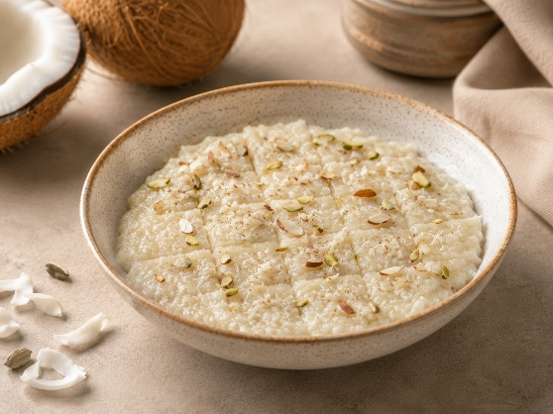
Image created with the use of AI

Ingrédients :
Cow’s milk – 200 ml (as needed)
Fresh grated coconut – 50 gm (1/4 cup)

Method of preparation :
- Cook the grated or finely chopped fleshy portion of coconut in milk until it reaches a thick consistency.
- Once done, spread the mixture evenly in a flat plate and allow it to cool slightly, then cut it into small pieces.

Contraindications:
- Diabetes
- Overweight / Obesity
- Lactose intolerance
- Sedentary life style with poor metabolism

